LS Command:

Ls –l: list all the directories and files

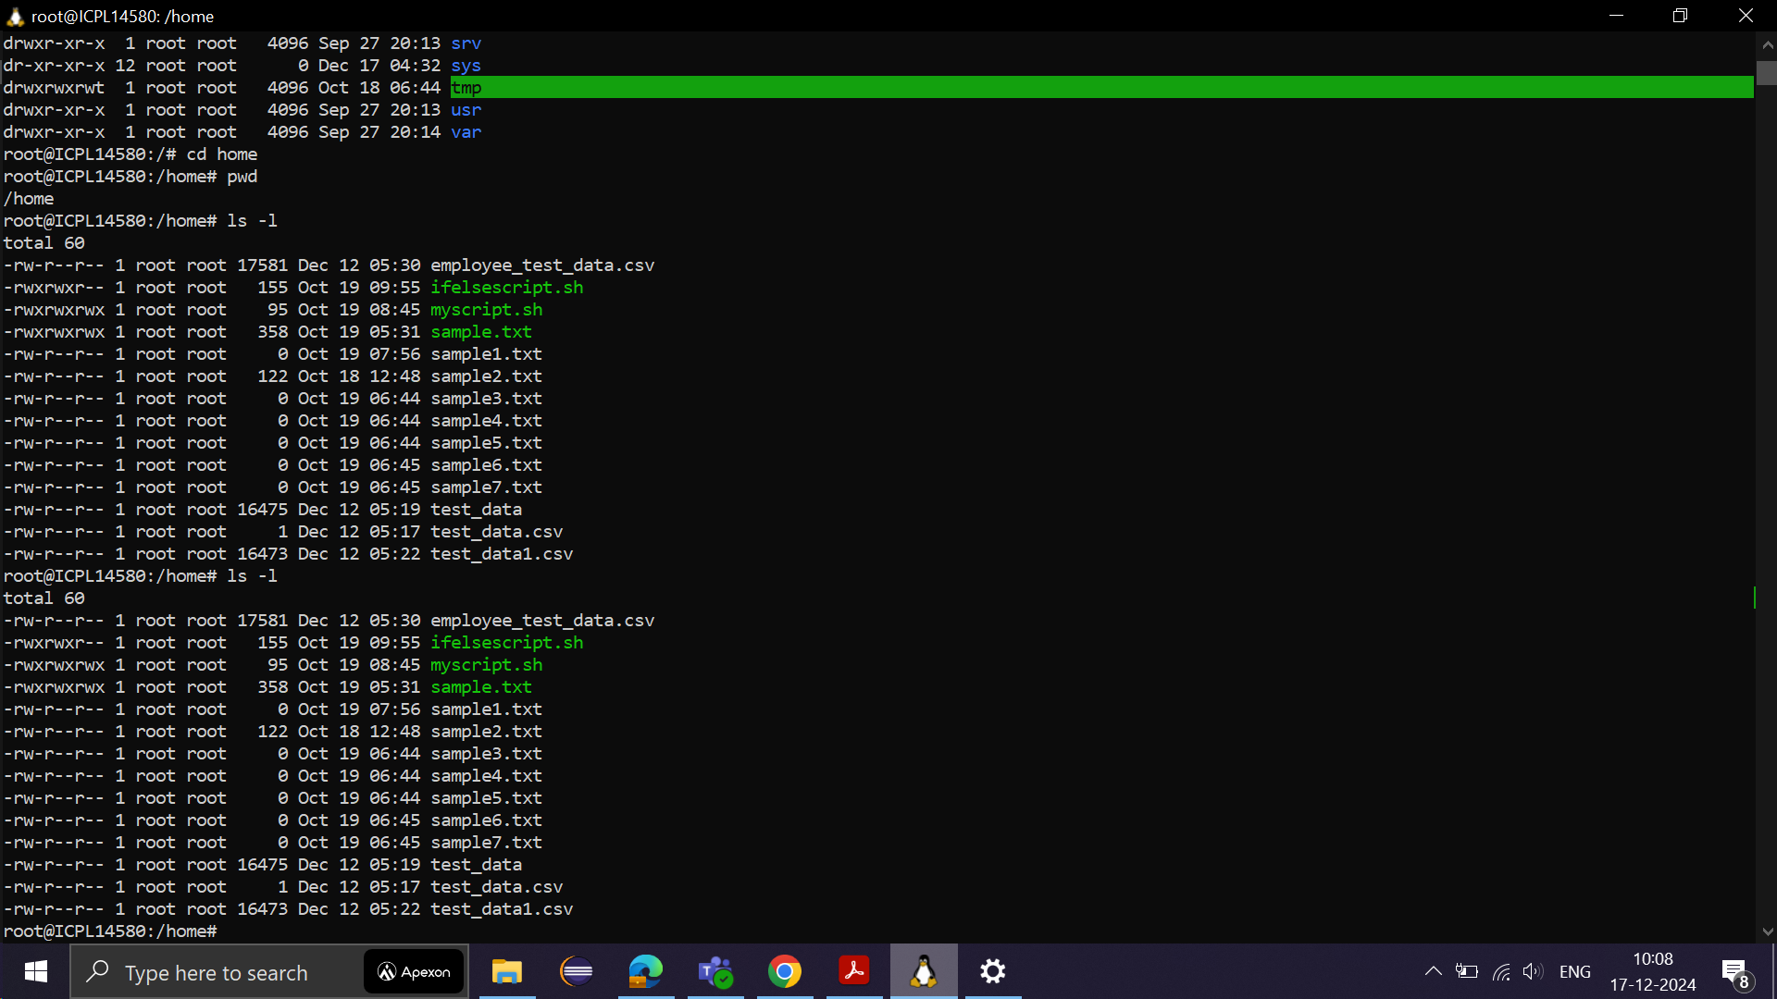

Example for ls –a: to list all the files including hidden files

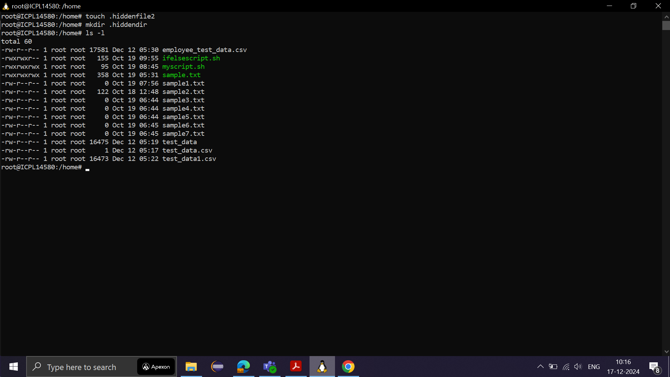

If we use ls –l hidden files and folders are not visible.

We need to use ls –a for hidden files and directories to display hidden files and directories along with normal files and folders.



ls –lS

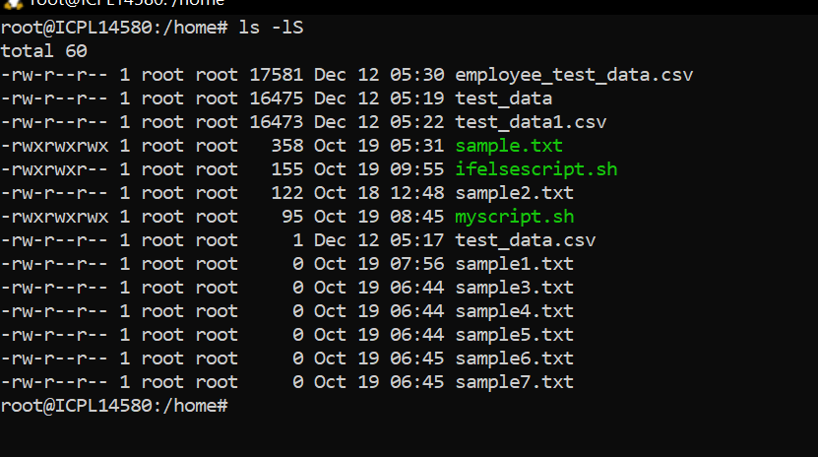Ex for ls –lhS: h for human readable size format 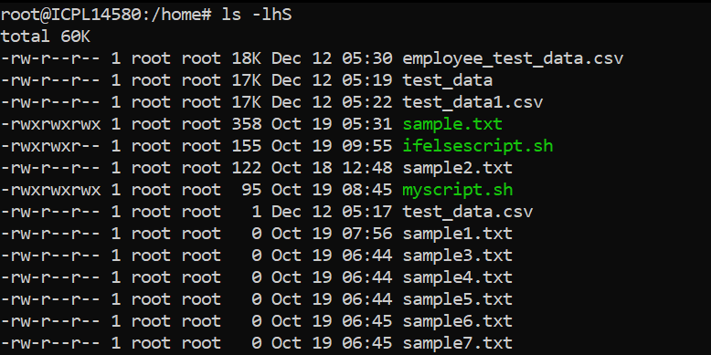

ls -i shows the inode number of each file, which is useful for managing hard links or

troubleshooting filesystem issues.

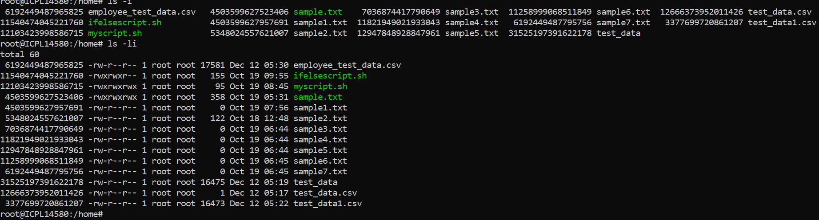

Ls with wildcard matching

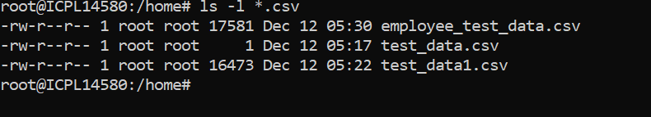

Ls –lh

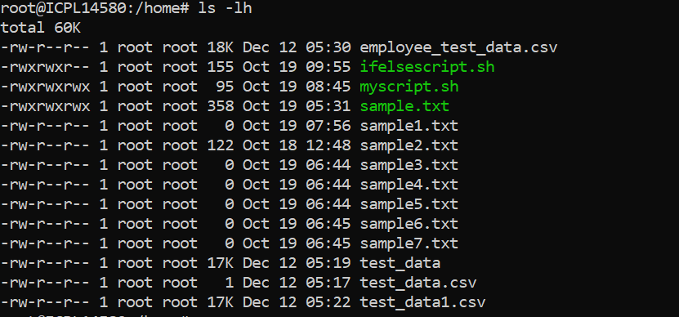

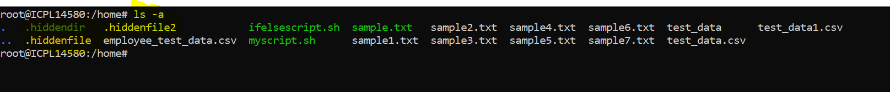

Ls –lR

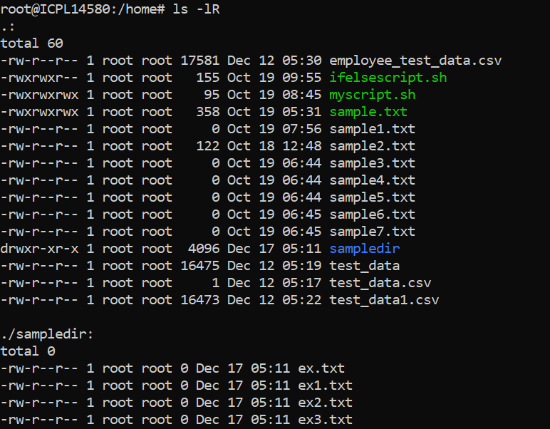

ls -d */ : Lists only the directories in the current path (no contents).



How would you use ls to display file types (e.g., directories, regular files, symbolic

links)?

Use the -F option, which adds a / for directories, @ for symbolic links, and * for

executable files:

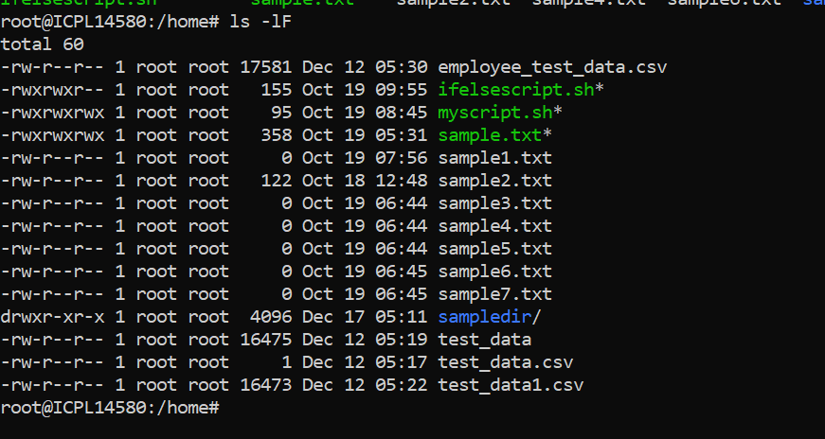

Cd command





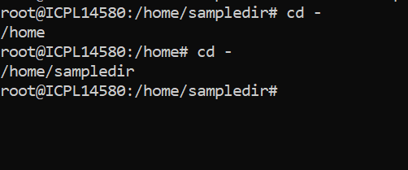

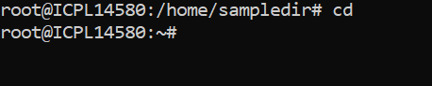



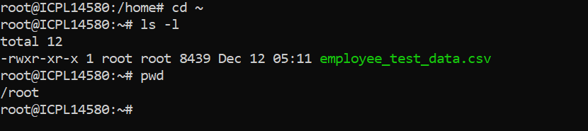

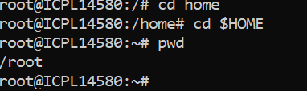

PWD command:

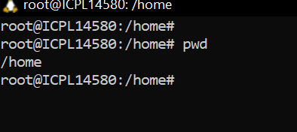

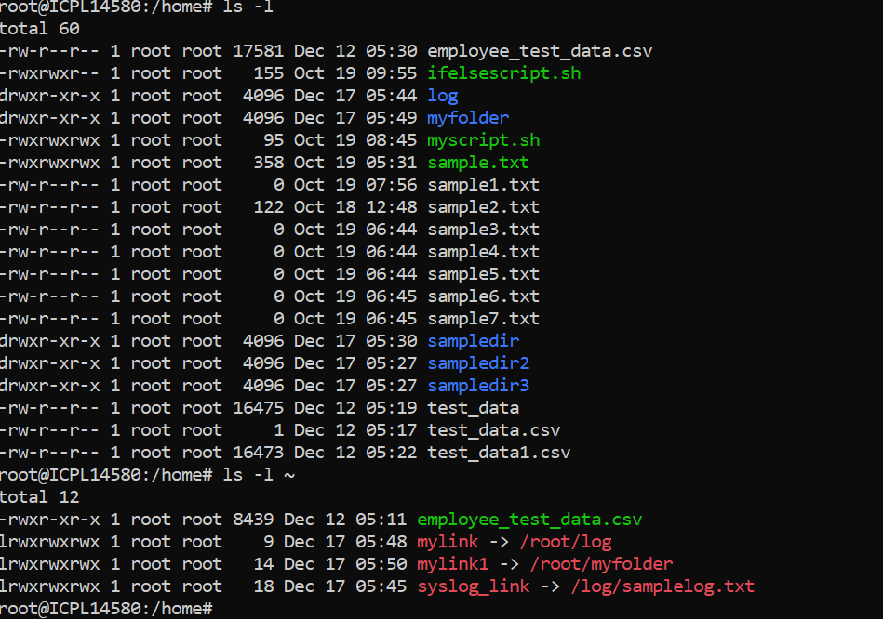

mkdir -p /path/to/new/dir

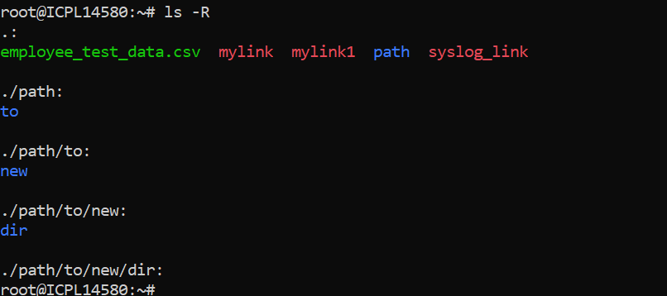

mkdir -p existing_dir

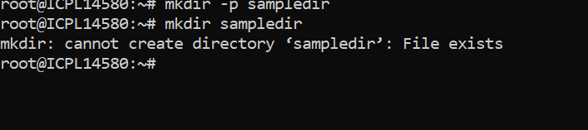

mkdir -m 755 new_dir

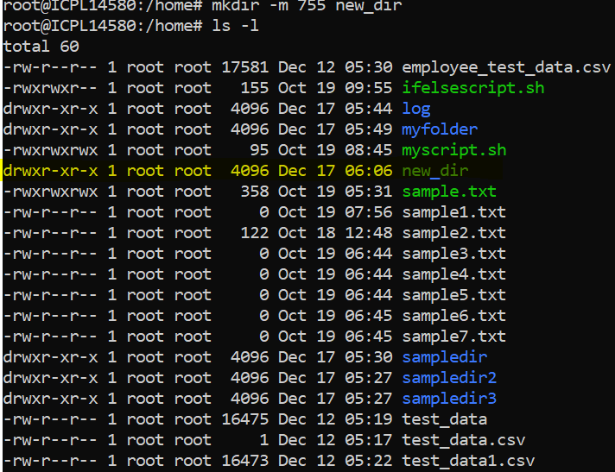

mkdir dir1 dir2 dir3

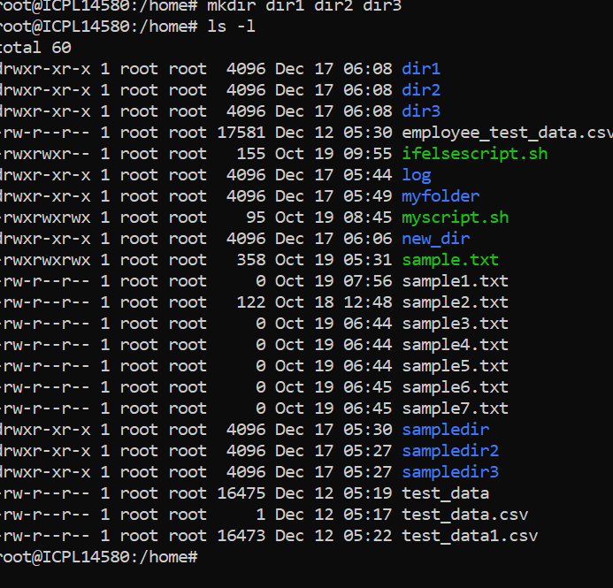

Rm command

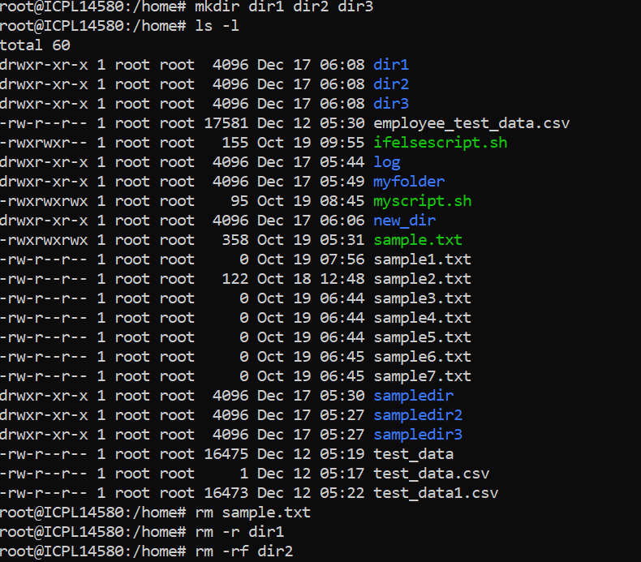

Command: rm –rf

1. This tells rm to recursively and forcefully delete **everything** starting from the root directory (/).

#### **Real-World Consequences**

When this happens:

1. **System Files Deleted**:

Critical system files like /bin, /lib, /etc are deleted, causing the operating system to fail.

1. **Immediate System Crash**:

Processes will start failing as system binaries and libraries disappear. Your terminal might stop working, and the system will eventually crash.

1. **Data Loss**:

All user data, including important files, will be lost.

1. **System Unrecoverable**:

Recovery might require reinstalling the operating system and restoring from a backup.

Command : rm *.log

